1)

#include<iostream>

using namespace std;

class Date

{

private:

int day,month ,year;

public :

date(int d, int m, int y)

{

day = d;

month = m;

year = y;

}

void nextday()

{

int d,m,y;

if(d==30)

{

d = d%30;

d = d+1;

m = m + 1;

cout<<"\nThe day after increment is : "<<d<<"/"<<m<<"/"<<y;

}

else

{

d = day + 1;

m = month;

y = year;

cout<<"\nThe day after increment is : "<<d<<"/"<<m<<"/"<<y;

}

}

};

int main()

{

Date ob1;

int x,y,z;

cout<<"Enter the day (1-30):";

cin>>x;

cout<<"\nEnter the month (1-12):";

cin>>y;

cout<<"\nEnter the year :";

cin>>z;

cout<<"\nTodays date is : "<<x<<"/"<<y<<"/"<<z;

ob1.date(x,y,z);

ob1.nextday();

}

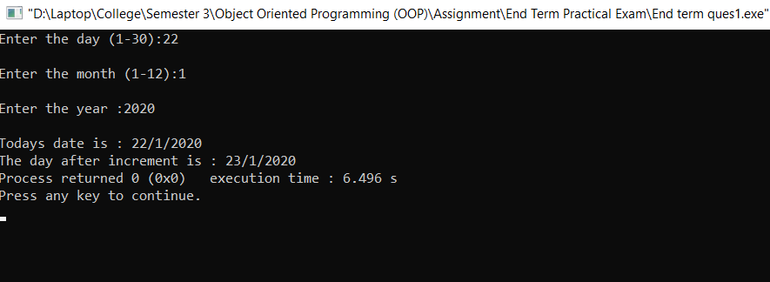

#include<iostream>

#include<cmath>

using namespace std;

template<class T>

class A

{

private:

int p,r,t;

int result;

public:

T Interest(T p, T r, T t)

{

return (p\*r\*t)/100;

}

T Interest2(T p, T r, T t)

{

T result = p \* pow((1+r/12), (12\*t));

return result - p;

}

};

int main()

{

A<float> ob;

int x,y,z;

cout<<"Enter the Principle : ";

cin>>x;

cout<<"\nEnter the rate of Interest : ";

cin>>y;

cout<<"\nEnter the time : ";

cin>>z;

cout<<"\nSimple Interest :"<<ob.Interest(x,y,z)<<endl;

cout<<"\nCompound Interest :"<<ob.Interest2(x,y,z)<<endl;

}

